CODICE EV3 Credits to Graduate Student Vincenzo Alba and PhD Giovanni Lugaresi for the code
This sheet is a reference for the JSON MQTT messages to be used to communicate with an EV3 that has Python’s script ‘codice ev3’ running on it, remember that everyone needs to be in the same network and connected to the same broker for the messages to be sent and received by the devices
Google doc link
! IMPORTANTE ! - la reference è stata creata guardando una versione dello script di fine 2019 che avevo sul pc a casa, controllare sugli EV3 in laboratorio se ora è cambiato (quasi di sicuro)

TOPICS
“payload_out” is the JSON sent by an EV3, “payload” is the JSON to send to the EV3.
Some topics recap the code used by the EV3 to better understand what the message being sent will do
Index structure:
Topic, payload, sender
- 'ev3_config': 'ev3', '1’, ‘2’, …, ‘12’ HOST
- 'ev3_configured' EV3
- 'scan' HOST
- 'time0_init' HOST
- 'stop' HOST
- 'sensor/on_change', 'sensor/rfid': 'ev3', 'sensor', 'value', 'ts' EV3
- 'sensor/on_demand/question' HOST
- 'sensor/on_demand/answer': 'ev3', 'sensor', 'value', 'ts' EV3
- 'motor/action/forever': 'ev3', 'motor', 'value'={angle1, angle2} HOST
- 'motor/action/abs': 'ev3', 'motor', 'value'={speed, angle} HOST
- 'motor/action/stop': 'ev3', 'motor', 'value' HOST
- 'motor/action/rel': 'ev3', 'motor', 'value' HOST
- 'motor/action/rel1verse': 'ev3', 'motor', 'value'={speed, angle} HOST
- 'motor/action/timed': 'ev3', 'motor', 'value'={t, speed} HOST
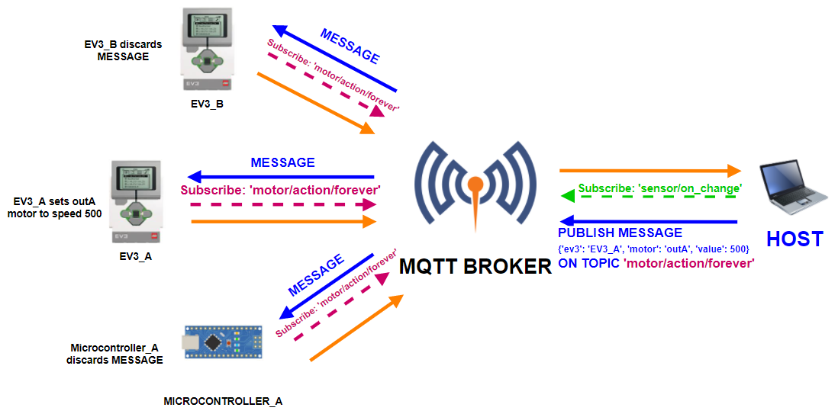

list structure:
'topic' #SENDER, description
payload keywords
#example
useful code

'ev3_config' # HOST, configure the Ev3.
payload: 'ev3', '1’, ‘2’, …, ‘12’
#EX: 'ev3': 'ev3_1', '1’: 'motor_station', ‘2’: 'Large', ...
ev3 = Ev3(ev3_name, motorA = payload["1"], typeA=payload["2"], motorB = payload["3"], typeB=payload["4"], motorC = payload["5"], typeC=payload["6"], motorD = payload["7"], typeD=payload["8"], sensor1 = payload["9"], sensor2 = payload["10"], sensor3 = payload["11"], sensor4 = payload["12"])

'ev3_configured' # EV3, notify completion of ev3 configuration.
payload_out = {'name':name}

'scan' # HOST, this topic is used to retrieve all the EV3s in the network
payload = {'name' : ev3_name}
payload = json.dumps(payload, indent=4)
client.publish('hello', payload, 2)

'time0_init' # HOST, initialize the system time.

'stop' # HOST, stop all motors and exit the script.

'sensor/on_change', 'sensor/rfid' # EV3, this topic identifies the sensors continuous stream of pubblications
color = colors[sensor.ev3sensor.value()]
[…]
payload_out = {'ev3': ev3.name, 'sensor': sensor.name, 'value': color, 'ts': ts}
[…]
sleep(0.1) # sensors output refreshing happens every ~0.1 sec #TODO send just on change

'sensor/on_demand/question' # HOST, this topic identifies the request to a sensor to give its output measure, reply by EV3 on 'sensor/on_demand/answer'
payload_out = {'ev3': ev3.name, 'sensor': sensor.name, 'value': sensor.ev3sensor.value(), 'ts': ts}

'motor/action/forever' # HOST, this topic identifies the action (run forever (speed specified in 'value'))
payload: 'ev3', 'motor', 'value' = {speed, angle}
motor.ev3motor.stop()
motor.ev3motor.run_forever(speed_sp = speed)

'motor/action/abs' # HOST, this topic identifies the action (abs_pos -> +240, abs_pos ->-240)
payload: 'ev3', 'motor', 'value' = {angle1, angle2}
motor.ev3motor.run_to_abs_pos(position_sp = angle1, speed_sp = 500, stop_action = 'hold')
sleep(2)
motor.ev3motor.run_to_abs_pos(position_sp = angle2, stop_action = 'hold')

'motor/action/stop' # HOST, this topic identifies the action (stop (stop_action specified in 'value'))
payload: 'ev3', 'motor', 'value' = {how}
motor.ev3motor.stop(stop_action = how) # stop_action = how ##TOCHECK commented?

'motor/action/rel' # HOST, this topic identifies the action (rel_pos -> +240, rel_pos ->-240)
payload: 'ev3', 'motor', 'value' = {angle}
motor.ev3motor.run_to_rel_pos(position_sp = angle, speed_sp = 500, stop_action = 'brake')

'motor/action/rel1verse' # HOST, this topic identifies the action (rel_pos -> +240, rel_pos ->-240)
payload: 'ev3', 'motor', 'value' = {speed, angle}
motor.ev3motor.run_to_rel_pos(position_sp = angle, speed_sp = speed, stop_action = 'hold')

'motor/action/timed' # HOST, this topic identifies the action (rel_pos -> +240, rel_pos ->-240)
payload: 'ev3', 'motor', 'value' = {t, speed}
motor.ev3motor.run_timed(speed_sp = speed, time_sp = t, stop_action = 'brake')

COMPONENTS
Here are listed just the most important parts of the code useful to build the MQTT messages

#colors = ('unknown', 'black', 'blue', 'green', 'yellow', 'red', 'white', 'brown')

colors = ('unknown', 'unknown', 'blue', 'unknown', 'yellow', 'red', 'white', 'yellow') #unkn/black/green and yellow/brown perceived as the same colors#

ports = ('in1', 'in2', 'in3', 'in4', 'outA', 'outB', 'outC', 'outD')

• EV3
class Ev3:

global mA, mB, mC, mD, s1, s2, s3, s4

def __init__(self, name, motorA=None, typeA=None, motorB=None, typeB=None, motorC=None, typeC=None, motorD=None, typeD=None,

sensor1=None, sensor2=None, sensor3=None, sensor4=None): #function called whenever an instance of the class station is initialized
[...]
mA = Motor(typeA, 'outA', motorA) # type, port, name
[...]

s1 = Sensor('in1', sensor1) # port, name

[...]
elif sensor4 == 'stop': # sensor4 if named ‘stop’ works as stop button with touch sensor, otherwise it is a normal color sensor

s4 = TouchSensor('in4', sensor4)

else:

s4 = Sensor('in4', sensor4)

• Motor
class Motor:

types = ('Medium', 'Large')
motors_list = []

def __init__(self, type, port, name):
[...]
Motor.motors_list.append(self)

• Sensor
class Sensor:
sensors_list = []

def __init__(self, port, name):
Sensor.sensors_list.append(self)

• TouchSensor
class TouchSensor:
touchsensors_list = []

def __init__(self, port, name):
TouchSensor.touchsensors_list.append(self)

